TEST REPORT

**Table of Contents**

Quality Status ……………………………………………………………………2

Test Environment Covered…………………………………………………2

List of Existing Defects……………………………………………………….3

**Quality Status**

The quality of the E- Commerce Application OpenCart , version 13.56 is better than the previous versions. In this version, the important issues still exits and hence we ‘Not Recommend this version for Release’.

**Test Environments Covered**

We have tested Open Cart Web Application Version 13.56 in all the below different Test

Environments:

• Windows 10 – Chrome, Firefox, IE 11 and Edge

• Mac OS – Safari Browser

• Linux Ubuntu OS – Firefox

• Android Mobile OS – Chrome

• iPhone Mobile OS – Safari

**Defects by Functional Area**

The below is the count of existing defects by Functional Area:

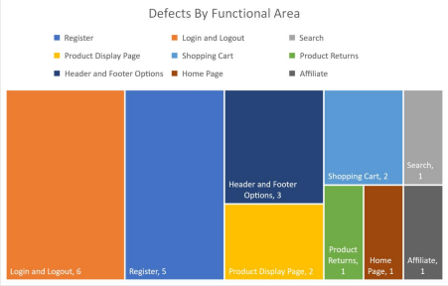

**List of Existing Defects**

The below are the list of existing defects which are still existing in the Open Cart Web Application  Version 13.56:

|  |  |  |
| --- | --- | --- |
| **Defect#** | **Description** | **Severity** |
| TU1-I2 | Thank you for registering' email is not received to the registered email  address after registering an account | Minor |
| TU1-I13 | 'Privacy Policy' Checkbox field in 'Register Account' page is not marked with  red colour * symbol | Minor |
| TU1-I10 | 'Telephone' field in 'Register Account' page is accepting the spaces , invalid phone no and not  showing warning message | Critical |
| TU1-I23 | 'Password' and 'Password Confirm' fields in 'Register Account' page are  accepting simple passwords | Major |
| TU1-I9 | Previous login session should not be maintained and user should be logged out | Minor |
| TU1-I3 | Negative, Null and Zero values are accepted by the Qty field in Product  Display Pages | Minor |
| TU1-I21 | Warning message informing the User to provide positive quantity is not  getting displayed on updating the quantity with negative, zero or blank in the  'Shopping Cart' page | Minor |
| TU1-I15 | Options are not displayed in the 'Select' dropdown list of 'Canon EOS 5D'  product display page | Major |
| TU1-I10 | Clicking on the first Hero image is taking us to a wrong Product Display Page | Minor |